Number Topic | Sparx Maths Independent Practice Codes
Calculating with roots and fractional indices | U851, U985, U772, U299
Converting recurring decimals to fractions | U689
Surds | U338, U663, U872, U499
Rationalising the denominator | U707, U281
Error intervals | U657, U301, U587
Fractions | U224, U538, U793
Factors, multiples and primes | U739, U250
Percentage change | U671, U332, U988
Standard form | U330, U534, U264, U290
Error intervals | U657
Ratio & Proportion Topic | Sparx Maths Independent Practice Codes
Ratio | U687, U753, U176, U577, U921, U865
Speed | U151
Density and pressure | U910, U527
Proportion | U721, U357, U610
Algebraic direct and inverse proportion | U407, U138
Compound units: Density problem solving | U910

Algebra Topic | Sparx Maths Independent Practice Codes
Linear equations | U325, U870, U599
Linear inequalities | U759, U738, U145, U337
Index laws | U662
Linear simultaneous equations | U760, U757, U836, U137
Linear graphs and coordinates | U315, U669, U477, U848, U377
Quadratic graphs and equations | U989, U667, U228, U601
Expanding triple brackets | U606
Operations with algebraic fractions | U685, U457, U824
Factorising quadratic expressions: ax²+bx+c | U858
Simplifying algebraic fractions | U294
Factorising to solve quadratics equations | U228, U960
Using the quadratic formula | U665
Completing the square to solve quadratics | U397, U589
Quadratic equations in context | U150
Quadratic simultaneous equations | U547
Index laws | U235, U694, U662
Equation of a straight line: Perpendicular lines | U898
Quadratic graphs: Turning points | U769
Quadratic simultaneous equations on graphs | U875
Exponential graphs | U229
Exponential growth and decay problems | U988
Trigonometric graphs | U450
Graph transformations | U598, U487, U455
Velocity-time graphs | U937, U562, U611
Rate of change graphs | U638, U652, U862
Estimating gradient from a curve | U800
Estimating area under a curve | U882
Equation of a circles and tangents | U567
Linear inequalities as graph regions | U747
Quadratic inequalities | U133
Functions | U637, U895, U448, U996
Recurrence relations | U171
Quadratic sequences | U206
Iteration and numerical methods | U434, U168
Algebraic proof | U582

Geometry Topic | Sparx Maths Independent Practice Codes
Area | U226, U343, U950
Volume | U786, U174, U915
Angles | U655, U826, U329, U427
Pythagoras’ theorem | U385
Trigonometry | U605, U283, U545
Transformations | U196, U799, U696, U519, U766
Congruence proofs | U866, U887
Enlargements | U134
Describe combined transformations | U766
Circle theorems: Angles inside a circle | U459, U251
Circle theorems: Tangents and chords | U489, U130
Circle theorems problems | U808
Prove circle theorems | U807
Volume of frustums | U350
Volume: Problem solving | U543, U426
Similar Shapes: Area and volume | U630, U110
Pythagoras’ Theorem in 2D and 3D | U385, U541
Right-angled trigonometry: Problem solving | U319, U283, U545, U967
3D trigonometry | U170
The area rule | U592
Sine rule | U952
Cosine rule | U591
Trigonometry and bearings | U164
Vectors problems | U781, U560

Probability Topic | Sparx Maths Independent Practice Codes
Calculating probabilities | U408, U510, U683, U580
Expected outcomes | U166
Tree diagrams | U558, U729
Set notation | U748, U296
Product rule for counting | U369
Conditional probability | U246, U821, U806
Probability from Venn diagrams | U476, U748, U699
Statistics Topics | Sparx Maths Independent Practice Codes
Averages | U569, U877, U717
Averages with grouped data | U877
Sampling | U162
Scatter graphs | U199, U277, U128
Frequency polygons | U840
Cumulative frequency diagrams | U182, U642
Box plots | U879, U837, U507
Frequency polygons | U840
Histograms | U814, U983, U267
Capture-recapture | U328

How to use the codes for independent revision on Sparx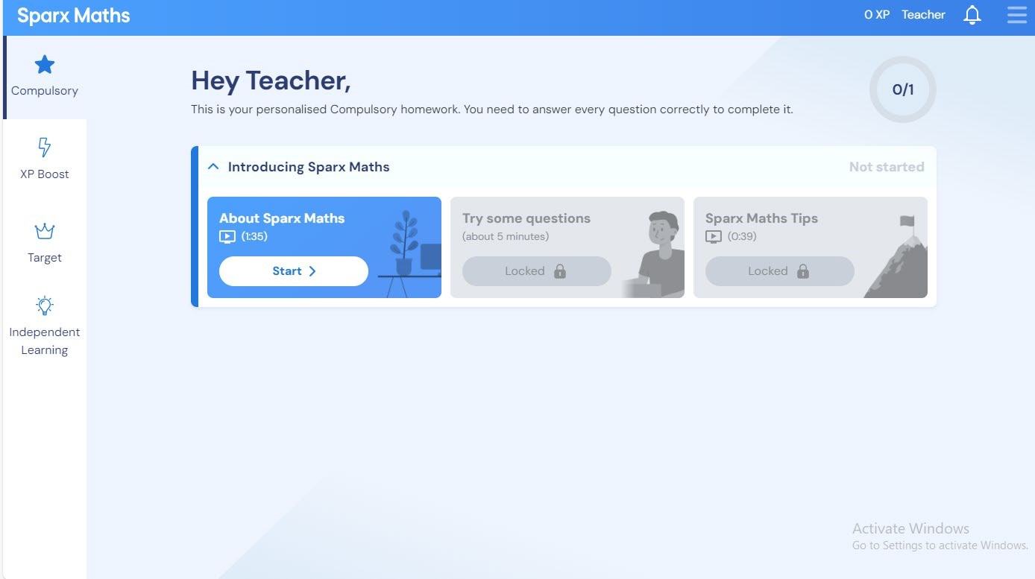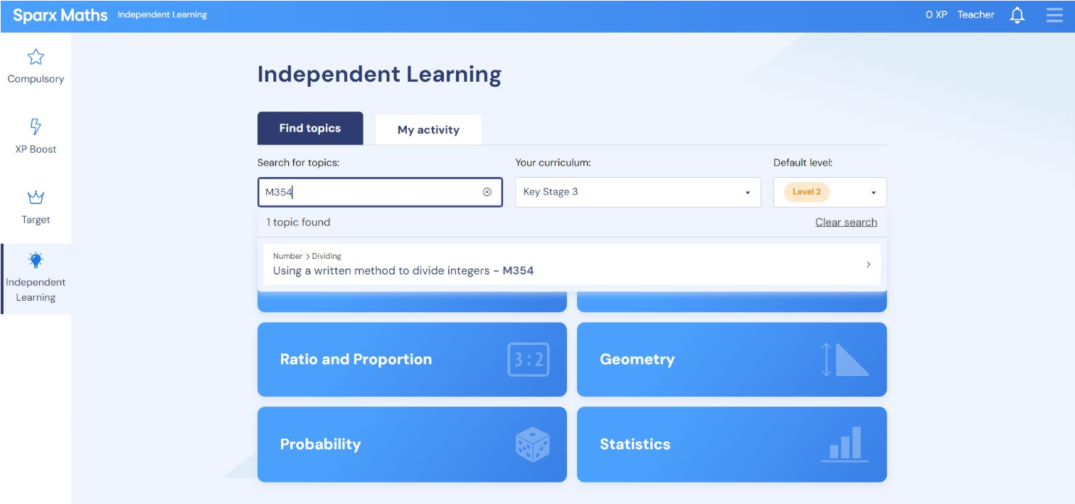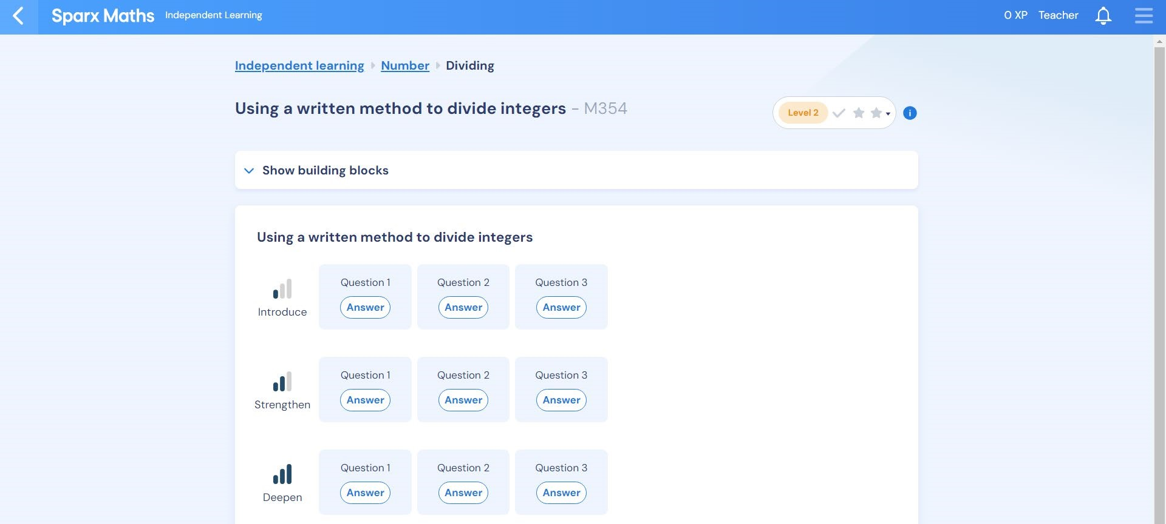
From the
homepage, click
the ‘Independent
Learning’ tab to
open this page.
On this dropdown, you can change
the curriculum level (Sparx Maths
sometimes categorises things at a
different stage than we do)
You can change
the difficulty
level to suit your
confidence level
Type in the
code from
the revision
list to bring
up the
revision for
that topic
This will
bring up
the task –
click on
each
question to
revise the
topic in
more
depth
If you are finding it difficult
you can try some of the
‘building blocks’ tasks which
will help you with the prior
knowledge you need to
access the main task

