Number Topic | Sparx Maths Independent Practice Codes
Ordering positive integers | U600
Ordering decimals | U435
Ordering negative numbers | U947
Adding and subtracting positive integers | U417
Multiplying and dividing positive integers | U127, U453
Adding and subtracting negative numbers | U742
Multiplying and dividing negative numbers | U548
Adding and subtracting decimals | U478
Multiplying and dividing with place value | U735
Multiplying and dividing with decimals | U293, U868
Order of operations | U976
Prime numbers, prime factorisation | U236, U739
Factors, multiples, HCF and LCM | U211, U751, U529
Powers and roots | U851
Using standard form | U330, U534
Calculating with standard form | U264, U290, U161
Equivalent fractions and simplifying fractions | U704, U646
Mixed numbers and improper fractions | U692
Ordering fractions | U746
Addition and subtraction of fractions | U736, U793
Multiplication and division of fractions | U475, U544
Converting and ordering fractions, decimals and percentages | U888, U594
Fractions of amounts | U881, U916
Percentages of amounts | U554, U349
Percentage change | U773, U671
Reverse percentages | U286, U278
Simple interest | U533
Rounding | U480, U298
Fractions | U224, U538, U793
Factors, multiples and primes | U739, U250
Percentage change | U671, U332, U988
Standard form | U330, U534, U264, U290
Error intervals | U657

Algebra Topic | Sparx Maths Independent Practice Codes
Algebraic expressions | U613
Collecting like terms | U105
Substitution | U201, U585, U144
Expanding brackets | U179, U768
Factorising expressions | U365
Index laws | U235, U694, U662, U103
Changing the subject | U556
Coordinates | U789, U889
Midpoints | U933
Plotting straight line graphs | U741
Equations of straight line graphs | U315, U669
Parallel lines | U377
Distance-time graphs | U403, U914, U462, U966
Quadratic graphs | U989, U667
Linear equations | U755, U325, U870, U505, U599
Quadratic expressions and equations | U178, U228
Linear sequences | U213, U530, U498, U978
Other sequences | U958, U680
Linear equations | U325, U870, U599
Linear inequalities | U759, U738, U145, U337
Index laws | U662
Linear simultaneous equations | U760, U757, U836, U137
Linear graphs and coordinates | U315, U669, U477, U848, U377
Quadratic graphs and equations | U989, U667, U228, U601

Ratio & Proportion Topic | Sparx Maths Independent Practice Codes
Simplifying ratios | U687
Sharing amounts in a ratio | U753, U577
Converting between ratios, fractions and percentages | U176
Direct proportion | U721, U640
Inverse proportion | U357, U364
Proportion graphs | U238
Units of measure: Length, Mass and Capacity | U102, U388
Units of measure: Time | U902
Units of measure: Area | U248
Currency conversion | U610
Conversion graphs | U652, U638, U862
Compound units: Speed | U151
Ratio | U687, U753, U176, U577, U921, U865
Speed | U151
Density and pressure | U910, U527
Proportion | U721, U357, U610

Geometry Topic | Sparx Maths Independent Practice Codes
Properties of 2D shapes | U121, U849
Properties of 3D shapes | U719
Nets of 3D shapes | U761
Angles: Measuring, Drawing and Estimating | U447
Angle on a line and about a point | U390
Vertically opposite angles | U730
Angles on parallel lines | U826
Angles in a triangle | U628
Combining angle facts | U655
Angles in a quadrilateral | U732, U329
Angles in polygons | U427
Bearings | U525, U107
Translations | U196
Reflections | U799
Enlargements | U519
Rotations | U696
Congruence | U790, U866
Area and perimeter of simple shapes | U993, U970, U351, U226
Area of triangles, parallelograms and trapeziums | U945, U575, U424, U265, U343
Circles | U767
Circumference | U604, U221
Circle area | U950, U373
Surface area | U929, U259, U871
Volume of cuboids | U786
Volume of prisms and cylinders | U174, U915
Similar shapes | U551, U578
Scale diagrams | U257
Properties of 2D shapes | U121, U849
Area | U226, U343, U950
Volume | U786, U174, U915
Angles | U655, U826, U329, U427
Pythagoras’ theorem | U385
Trigonometry | U605, U283, U545

Probability Topic | Sparx Maths Independent Practice Codes
Probability scale | U803
Probability of single events | U408, U510, U683
Experimental probability | U580
Expected outcomes | U166
Calculating probabilities | U408, U510, U683, U580
Listing elements in a set | U748, U296
Probability from Venn diagrams | U476
Frequency trees | U280
Sample space diagrams | U104
Tree diagrams | U558, U729
Statistics Topics | Sparx Maths Independent Practice Codes
Collecting data, frequency tables | U322, U120
Two-way tables | U981
Bar charts | U363, U557
Pictograms | U506
Pie charts | U508, U172
Stem and leaf diagrams | U200, U909
Mode | U260
Mean | U291
Median | U456
Range | U526
Choosing averages | U717
Scatter graphs | U199, U277, U128
Averages | U569
Averages with grouped data | U877
Sampling | U162
Frequency polygons | U840

How to use the codes for independent revision on Sparx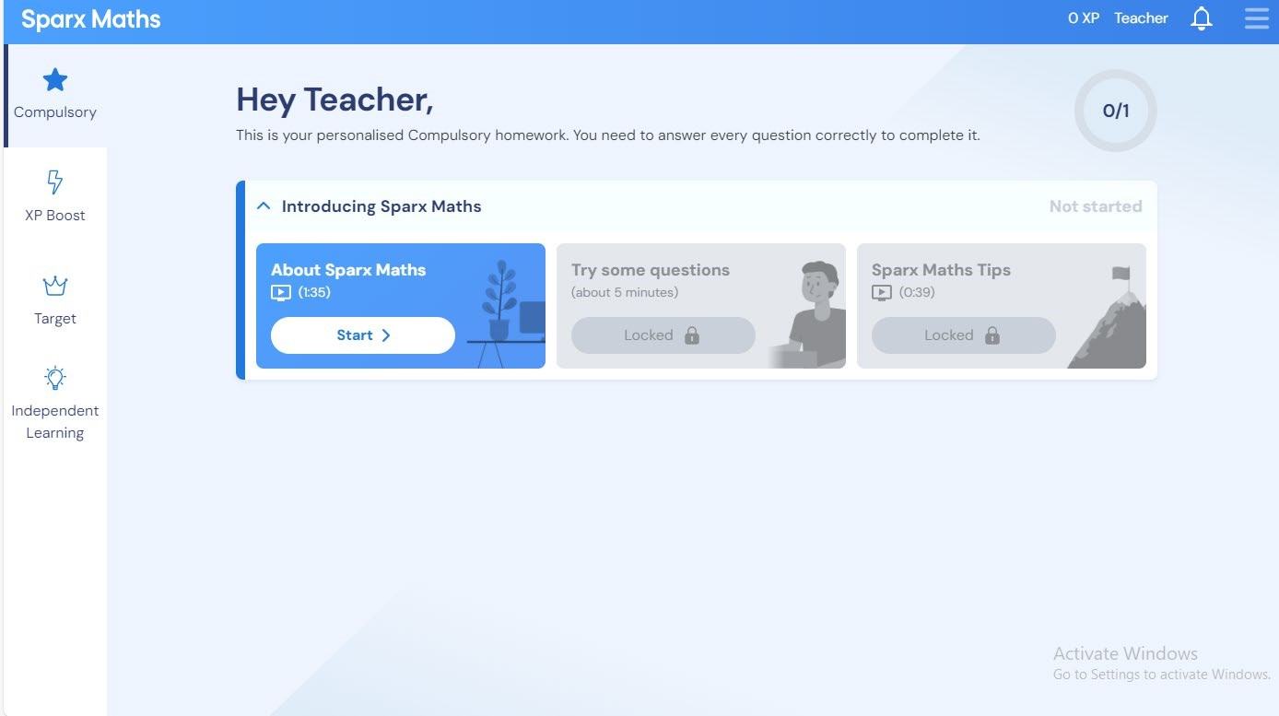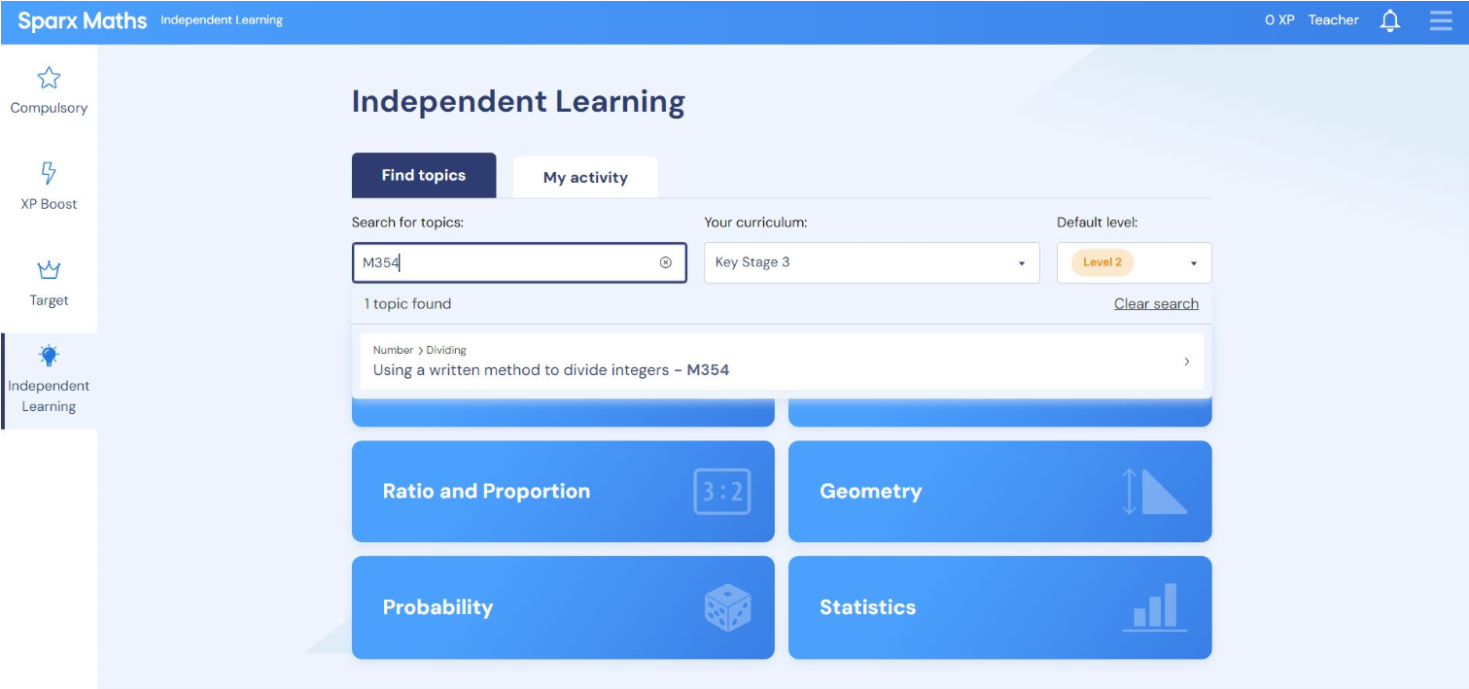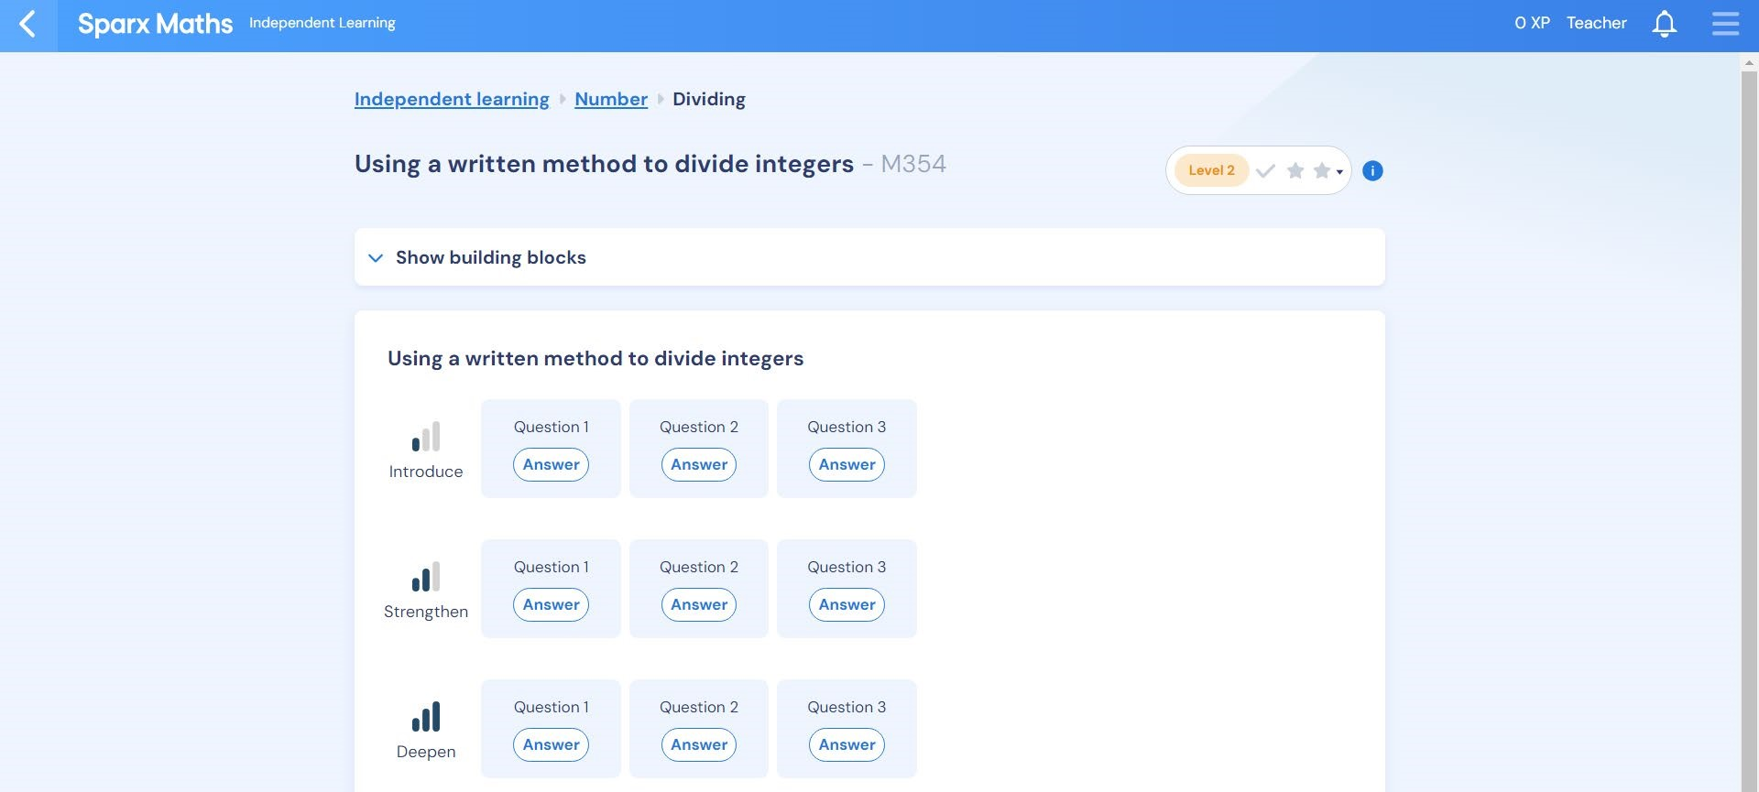
From the
homepage, click
the ‘Independent
Learning’ tab to
open this page.
On this dropdown, you can change
the curriculum level (Sparx Maths
sometimes categorises things at a
different stage than we do)
You can change
the difficulty
level to suit your
confidence level
Type in the
code from
the revision
list to bring
up the
revision for
that topic
This will
bring up
the task –
click on
each
question to
revise the
topic in
more
depth
If you are finding it difficult
you can try some of the
‘building blocks’ tasks which
will help you with the prior
knowledge you need to
access the main task

